

A PROJECT REPORT

ON

KAB HOSPITAL MANAGEMENT SYSTEM

DONE BY

SriPriya.Goru

(EBEON0920321174)

Under the Guidance of,

**Mr. V JAYANTH**

**Technical Trainer**

**NASSCOM PROJECT**

**­**

**ARISE**

**ONCAMPUS**

**SOFTWARE DEVELOPER TRAINEE**

Tambaram, Chennai-600045 (Tamil Nadu)­­

2020

**ABSTRACT**

There is name for this project which is Airline Reservation System. The software is providing options for viewing different flights available within a different timing for a specific day. That provide customers within facility to able to book ticket smoothly. The customers can modify and able to cancel the ticket for any reason. That prepare within a role and policies. A polices and role allow the customers modify the specific options. For example, the customers can’t modify the price or change in the prices. That is not allowed or changing in the time. The software should option for checking availability of the tickets. That is important for the customers to get message if the ticket unavailable. That will be displayed into customers. The customers should be noted when the change has been made or any further changes.

**TABLE OF CONTENT**

**S. TITLE PAGE NO**

ABSTRACT

**INTRODUCTION TO THE STUDY**

• System Context

•Functional Requirements

• Non-Functional Requirements

• Project Scope

• Specific Requirements

•User Requirements

**2. OBJECTIVES OF THE STUDY**

**3.Problem Definition**

* Business Impact
* Manual system
* Technical system

**4.  Functional Requirements**

• User Accounts

• Registration and creation of user profile

• Checking Availability

• Confirm Ticket

• Reschedule Ticket

• Cancellation

• Update Profile

•View Ticket Status

• Query Flight Details

• Telephone access

5**. Future Requirements**

**6. Future Scope**

**7. CONCLUSION**

**8. REFERENCES APPENDIX-I SNAPSHOTS**

**SOURCE CODE**

**CHAPTER – 1**

**INTRODUCTION TO THE STUDY**

**Introduction:**

JSP technology is used to create web application just like Servlet technology. It can be thought of as an extension to servlet because it provides more functionality than servlet such as expression language, jstl etc.

A JSP page consists of HTML tags and JSP tags. The jsp pages are easier to maintain than servlet because we can separate designing and development. It provides some additional features such as Expression Language, Custom Tag etc.

The scripting elements provides the ability to insert java code inside the jsp. There are three types of scripting elements:

• script let tag

• expression tag

• declaration tag

There are many JSP action tags or elements. Each JSP action tag is used to perform some specific tasks. The action tags are used to control the flow between pages and to use Java Bean. The Jsp action tags are given below.

JSP Action Tags Description:

jsp:forward forwards the request and response to another resource.

jsp:include includes another resource.

jsp:useBean creates or locates bean object.

jsp:setProperty sets the value of property in bean object.

jsp:getProperty prints the value of property of the bean.

jsp:plugin embeds another components such as applet.

jsp:param sets the parameter value. It is used in forward and include mostly.

jsp:fallback can be used to print the message if plugin is working. It is used in jsp:plugin.

**System Context**:

This section clearly depicts the environment and boundaries of the ARS and the entities with which it interacts. It helps us see how the system fits into the existing scheme of things. What the system will do by itself and what it expects other entities to do is clearly delineated.

Functional Requirements:

This section is the bulk of the document and precisely states the functions of the system – what it should do and what it should not. This section is split into subsections modelled after the real-world activities like reserving tickets, rescheduling tickets etc. Freedom from ambiguity and navigability were kept in mind while documentation. A consistent terminology has been followed throughout and the terms are explained in the appendix. The subsections follow a logical sequence that reflects the real world. For example, a customer cannot reschedule a ticket unless he has bought one earlier and cannot buy one unless he has checked its availability.

Non-functional Requirements:

These are quality requirements that stipulate the performance levels required of the system for various kinds of activities. Numerical lower and upper limits set conditions on the response times, access times etc of the system. Sometimes, trade-offs are necessary among various non-functional requirements.

Project Scope:

The airline booking website is an application stored in the user server. The purpose of the website is to resolve the client to allow website users to perform tasks related to booking an airline flight. Requirements are the description of how the system should behave, or of a system property or attribute. They are capabilities and objectives to which software must conform**.** Or in other words, they are constraints on the development process and describe.

Specific requirements:

The screen formats and organization. The interface should be easy to understand and user includes such as

The introductory screen will be the first t displayed which will allow the user to choose either of 2 options.

That view flight detail within booking a ticket.

Window format and organization when our customers choose some other option, then the information pertaining to that choice will be displayed in new window.

That ensure multiple windows to be visible on the screen.

The customers can switch among them.

The data format entered by the users will be alphanumeric.

The end message, when there were some exceptions raising error like entering invalid details, then error message will be displayed prompting the users to re-enter the details.

Hardware Interfaces

User requirements:

User properties like Name, Address, Age,

Associated with Flight Miles accumulated and Credit Card information.

Flight properties like Departing/Arriving City, Departure/Arrival dates and times, Miles, and an identifying Flight Number.

Flight Seat properties of identifying seat number, reserved and flight.

Associated to Flight-by-flight number.

**CHAPTER – 2**

**OBJECTIVES OF THE STUDY**

**Objective:**

2.1 The Airline Reservation System (ARS) is a software application to assist an airline with transactions related to making ticket reservations, which includes blocking, reserving, canceling and rescheduling tickets.

2.2 From the viewpoint of the airline –

2.2.1 Minimize repetitive work done by the system administrator and reservation clerks.

2.2.2 Maintain consistency among different access modes, e.g. by phone, by web, at the information desk and across different physical locations. The users should be basically taken through the same steps by the system as they go through in conventional desk-reservation systems.

2.2.3 Maintain customer information in case of emergency, e.g. flight cancellation due to inclement weather. The profile can also be used by the airline company to track user preferences and travel patterns to serve them better, plan routes, for better marketing and efficient scheduling of flights.

2.2.4 Maximize the revenue of the airline company by various means:

2.2.4.1 Increase awareness among frequent travelers about various special offers and discounts.

2.2.4.2 Minimize the number of vacant seats on a flight and maximize flight capacity utilization.

2.2.4.3 Maintain the capability to adopt a flexible pricing policy. The price of the tickets should be dynamically determined based on how early, before the date of departure, the customer buys the ticket.

2.3.1 Reduce effort and frustration for travelers in scheduling a trip, especially by reducing the search effort for the flight they need to take.

2.3.2 Show all possible combinations and itineraries available for a pair of origin-destination cities.

2.3.3 Reduce redundancy in the information required from the customers in order for them to buy tickets, create user accounts etc.

2.3.4 Check the validity of input data and give a feedback to the user in case of errors or inconsistency.

2.3.5 Provide flexible access modes to users – internet, telephone, PDA.

2.3.6 Protect customers’ privacy concerns.

2.3.7 Make it easy for travelers to check the ticket status or make changes to their trip.

**CHAPTER – 3**

**Problem Definition**

Airline Reservation System basically an interaction between Admin and Client easily through web. This project describes how to creates Interaction between clients to manage the reservation System of train and view the cost of ticket . This project contain only one categories namely ADMIN, through which client can easily interact with admin .

**Business Impact:**

This project can be very easily used in the process of various purposes in reservation of ticket of various airline. User can select the train and find the cost between source and destination. User can view the status of airline, view the seat of airline. He can also change their password , update their profile. Admin can also view user list.

The definition of our problem lies in manual system and a fully automated system.

**Manual system**:

The system is very time consuming and lazy. This system is more prone to errors and sometimes the approach to various problems is unstructured.

**Technical system:**

With the advent of latest technology if we do not update our system then our business result in losses gradually with time. The technical systems contains the tools of latest trend i.e. computers printers, fax, Internet etc. The systems with this technology are very fast, accurate, user-friendly and reliable.

**CHAPTER – 4**

**Functional Requirements**

**4.1 User Accounts**

4.1.1 The passenger, who will henceforth be called the ‘user’, will be presented with 3 choices by the reservation system, as the first step in the interaction between them. A user can choose one of these and his choice would be governed by whether he is a guest or a registered user and whether he wants to check the availability of tickets or also block/buy them. The terms ‘registered user’ and ‘guest’ are described below.

4.1.1.1 A user who has traveled by the airline earlier would have been given a user id and a password. He would have his personal information stored in the database referred to earlier in section 2 as ‘DB-user’. This ‘personal information’ would be henceforth referred to as ‘profile’. Such a user with a profile in DB-user shall be called a ‘registered user’. A registered user will be able to check the availability of tickets as well as block/buy a ticket by logging into the system.

4.1.1.2 A new user, on the other hand, would either have to

register himself with the system by providing personal information or

log into the system as a guest.

In case of ‘a’, the new user becomes a registered user.

In case of ‘b’, the new user would remain a guest.

A guest can only check the availability of tickets and cannot block or buy tickets.

But a registered user can also act as a guest if he only wants to check the availability of tickets. ‘Availability of tickets’ always refers to viewing the flight schedule for given days, the price of tickets and any discount offers. The system shall present the user with an option to exit from the system at any time during the following processes.

**4.2 Registration and creation of user profile**

**The system shall require a user to register, in order to carry out any transactions with it except for checking the availability of tickets. It will ask the user for the following information at the least – a user id, a password, first name, last name, address, phone number, email address, sex, age, preferred credit card number. The system will automatically create a ‘sky miles’ field and initialize it to zero in the user’s profile.**

**4.3 Checking Availability**

4.3.1 After logging in a user (either a registered user or a guest), the system shall request him to enter the following details – origin city and destination city. “City’ is a generic term and refers to a city or town as the case may be. The origin and destination cities would be entered as text.

The system shall now refer to the flight schedule database, referred to as ‘DB-geography’ in section 2, and check if there is any ambiguity with the names of the cities. In case there are more than two cities with same name as entered by the user, the system shall list all of them (with more qualifications) and ask the user to select one of them. In case, either the origin or destination cities are not listed in DB-geography as being directly serviced by the airline, the system shall suggest the nearest city to which service is available, including the distance of the destination city from this nearest city.

After the origin and destination cities are ascertained, the system shall now access the flight schedule database, referred to as ‘DB-schedule’ in section 2, and checks if there is a direct operational service between the two cities. If not, the system shall suggest possible routes and transfer points using a ‘route selection algorithm’. The user shall now be presented with a choice of either selecting one of the routes. In case he selects a route, the system shall fill in the intermediate stop over points and create a multiple trip itinerary for the user.

4.3.4 The system shall now ask the user to enter the following details – class, one-way or round trip, departure date and the number of adult passengers, children and senior citizens.

‘Class’ refers to business class/first class/club class/smoking/non smoking. This choice shall be made by the user through a drop down menu indicating all the possible combinations of choices.

One-way/round trip shall be either a drop down menu or a check box selection. ‘Departure date’ refers to either a single date or a range of dates, entered through a calendar-like menu. This menu shall not show dates in the past or those dates that are too ahead in the future(as determined by the airline policy). In case, the trip is a round trip, the system shall also ask the user to enter the departure date on the return trip.

Having taken all the above input from the user, the system checks for any false entries like the departure date on the return trip being earlier than the departure date on the onward trip. In case of incompatibility, the system shall display a suitable error message and prompt the user to enter the information correctly.

Having taken all of the information as laid out above in 4.3.1 and 4.3.4, the system shall now access the flight schedule database ‘DB-schedule’ and queries it using the input provided by the user.

The system queries the reservation database ‘DB-reservations’ to check which of the flights on the schedule have seats available. The system displays the results in a suitable form (a tabular form) with the following information depicted – for each flight number – the flight number, departure time in origin city, arrival time in destination city, the duration of the flight (taking into account the possibility of a change of time zone) and the number of seats available on that flight.

There can be several flights between two cities and all of them will be listed for the particular date that the user wants to depart from the Origin City. In case, the user has entered a range of dates, the system shall display all the flights for all those dates in the range.

If the user has requested a round trip, the system shall display two tables – one for the onward trip and one for the return trip. There will be a check box in front of each line in the table representing a flight with available seats.

The user is now asked to check one of the boxes reflecting a choice of a flight number and time. In case of a round trip, the user is asked to check one box each in the two tables.

The system shall now display the price of the ticket for the trip. This will be the sum of the prices for all the members of the travel party being represented by the user.

The system shall also list any rules regarding the cancellation of tickets – what percentage of the price will be refunded within what date ranges. This will be displayed as a table.

**Making Reservations/Blocking/Confirmation**

4.4.1 After having taken the user through the step 4.3, Checking Availability, The system will now ask the user if he wishes to block/buy the ticket. If yes, and

if the user has been a guest, he will have to first register and become a registered user and then log onto the system.

If the user is already a registered user, and if he has logged on already, he can block/buy the ticket, but if he has been acting as a guest, he will have to log on.

Having ensured that the user is logged on validly according to 4.4.1, the system compares the departure date with the system date. If the departure date falls within 2 weeks of the system date, the system informs the user that he has no option to block the ticket and asks him if he would like to buy it.

If the difference between the departure date and system date is more than 2 weeks, the system asks the user if he would like to block or buy the ticket. The system informs the user that he can block the ticket at no cost now. It also informs him that if he chooses to block the ticket, he should make a final decision before 2 weeks of the departure date. The system shall send an email to the user, 3 weeks before the departure date as a reminder, in case he decides to block the ticket now.

Having taken the input from the user in 4.4.2, the system shall now proceed to update the reservation database DB-reservation. It will decrement the number of available seats on the particular flight for the particular class by the number of travelers being represented by the user.

In case of a blocking, the system makes a note of it in the database – to be used if the user doesn’t turn up before 2 weeks of the departure date. It generates a blocking number and displays it for the user to note down.

In case the user buys the ticket, the system accesses his profile and charges the price of the ticket to his credit card number. It simultaneously generates a confirmation number and displays it to the user for him to note down. The ticket has been reserved.

It adds the mileage of the trip (accounting for the number of travelers) to the skymiles in his profile.

**4.5 Confirm Ticket**

4.5.1 A user who has earlier blocked a ticket after going through the steps 3.2 through 3.4, is required to either confirm the ticket before two weeks of the departure date or the ticket stands cancelled.

To let the user confirm a ticket, the system shall first log him on and ask for his blocking number. Then it accesses DB-reservation and removes the check mark, which so far represented a blocked seat. The seat is now confirmed and reserved for the user.

The system accesses DB-user and charges the price of the ticket to the credit card number of the user. It simultaneously generates a confirmation number and displays it for the user to note down. The ticket has been reserved.

It adds the mileage of the trip (accounting for the number of travelers) to the skymiles in his profile.

**4.6 Reschedule Ticket**

The system shall present the user with an option to re-schedule his travel party’s trip. In order to do this, the system first logs on the user and requests his confirmation number. It will not allow a user to reschedule a blocked ticket but only a confirmed ticket. Using this, it queries DB-reservation and presents the details of the trip to the user, including but not limited to origin city, destination city, date of departure and date of arrival (in case the trip is a round trip).

The system shall now ask the user to select new dates from the calendar-menu. It now goes through step 4.3.

In case, there are no available tickets for the dates entered, it displays a suitable message informing him that rescheduling to that date is not possible.

In case there are tickets available, the system asks the user to select the flight number for the trip (another for the return trip if the trip is a round trip) and proceeds to update the database.

The system accesses DB-reservation and decrements the number of available seats on the flight(s) by the number of members in the user’s travel party. It then increments the entry for the previous flight by the same number to reflect an increase in the available seats on it as a result of the rescheduling.

The system now checks if there is any difference in the prices of the tickets. If so, it accesses DB-user and charges or credits the credit card as the case may be. The system generates a new confirmation number and displays it to the user.

**4.7 Cancellation**

The system shall also give the user an option to cancel a confirmed ticket or a blocked ticket.

The latter case is simpler and will be dealt with first – the system shall first log on the user and request the blocking number. Then it accesses DB-reservation and updates it by incrementing the number of available seats by the number of people in the user’s travel party.

In the former case, i.e., for a confirmed ticket, it asks for the confirmation number and accesses DB-reservation and presents the details of the trip as in step 3.6.1.

It then lists the applicable rules for cancellation of tickets and depending on the system date and the departure date, it displays the % of the amount that would be refunded if the user cancels the ticket.

After the user cancels the ticket, the system generates a cancellation number and displays it for the user to note down. It accesses DB-reservation and updates it by incrementing the number of available seats on that flight by the number of travelers in the user’s party. It accesses DB-user and credits the refund amount to his credit card number. The system then deducts the mileage of the trip (taking into account the number of travelers in his party) from the sky miles in his profile.

**4.8 Update Profile**

**The system shall enable the user to update his profile at any time. Changes can be made in fields including but not limited to address, phone number and preferred credit card number.**

**4.9 View Ticket Status**

The system shall allow a user to view all information about his trip. After logging him on, it asks for his blocking number or his confirmation number. It accesses DB-reservation and retrieves the details of the trip and presents them to the user in a convenient format, including any last minute changes to the flight timings etc. Such changes will be highlighted.

**4.10 Query Flight Details**

The system shall allow any user (registered or non registered) to access the details about the arrival and departure times of a flight by requesting the user to input the flight number and date. The system accesses DB-schedule and presents the time of arrival and departure.

**Telephone access**

The system shall be accessible through a touch-tone telephone. The telephonic interface shall, at the least, provide the customer with the facility to check availability of tickets and query flight details. The system shall walk the customer exactly through steps 4.3 and 4.9 respectively but through a telephonic interface.

**Non-functional Requirements**

5.1 Performance

5.1.1 Response time of the Airline Reservation System should be less than 2 second most of the time. Response time refers to the waiting time while the system accesses, queries and retrieves the information from the databases (DB-user, DB-schedule etc) (A local copy of flight schedule database is maintained as DB-schedule to reduce this access time)

ARS shall be able to handle at least 1000 transactions/inquiries per second.

ARS shall show no visible deterioration in response time as the number of users or flight schedule data increases

5.2 Reliability

ARS shall be available 24 hours a day, 7 days a week

ARS shall always provide real time information about flight availability information.

ARS shall be robust enough to have a high degree of fault tolerance. For example, if the user enters a negative number of passengers or a value too large, the system should not crash and shall identify the invalid input and produce a suitable error message.

5.2.4 ARS shall be able to recover from hardware failures, power failures and other natural catastrophes and rollback the databases to their most recent valid state.

5ARS shall provide a easy-to-use graphical interface similar to other existing reservation system so that the users do not have to learn a new style of interaction.

5.3.2 The web interface should be intuitive and easily navigable Users should be able to understand the menu and options provided by ARS.

5.3.3 Any notification or error messages generated by ARS shall be clear, succinct, polite and free of jargon.

**Integrity**

5.4.1 Only system administer has the right to change system parameters, such as pricing policy etc. The system should be secure and must use encryption to protect the databases.

5.4.2 Users need to be authenticated before having access to any personal data.

5.5 Interoperability

ARS shall minimize the effort required to couple it to another system, such as flight schedule database system.

**CHAPTER – 5**

**Future Requirements**

5.1 Support for waiting list functionality

5.1.1. ARS shall be made more flexible in ticket reservation handling, and shall accept waiting list for reservation.

5.1.2 The waiting list handling capability of ARS shall be made more advanced, by enabling it to send requests to the Flight Scheduler to schedule extra flights, depending on the demand in a particular corridor, and providing the wait listed passengers with a new flight.

5.2 The telephonic interface of the ARS shall be improved to support more functionality like allowing the customers to cancel a ticket etc., by incorporating security measures.

5.3 ARS shall be made more dynamic and helpful to the users by enabling it to send instant messages to the passengers, of a cancelled or rescheduled flight, through email, phone, fax etc., informing them about the change, and providing them with other feasible alternatives.

5.4 Information about the kind of meals served in a flight and the type of entertainment offered on a flight should be incorporated into the system.

Provide service integration with auto rental agencies and hotel chains.

Interface for the travel agents shall be provided in the future versions with additional features like informing them of any availability of seats on a flight which was earlier booked to capacity.

Choices like aisle or window seats shall be provided to the users.

The ARS shall be able to handle the situation where flight services are available to multiple airports in a single city.

**FUTURE SCOPE**

Airline Reservation System is one the modifications that were carried out in the Passenger Service System so that the working and availability of Service area can be broadened.

This is basically an interface of Global distribution System to carry out reservations on the desired airline from any place. Airline Reservation System make the life of passengers very easy as they don’t need to stand in queues for getting their seats reserved and they can easily make reservations on any airline just from a single system.

From the user\'s point of view the interface of the system is very easy and no technical knowledge is required to use the system. But to use this reservation system, customers need to create an account first and have to fill all the information required. If a client had already booked a ticket, he can also reschedule his booking for any other desired flight.

**CONCLUSIONS**

There was a lot of fun in making this project. This project was very useful to us as it provided us the inside view of the planning and implementation of the data base. In this project we had to think about the various options which we can provide to user. The implementation was not easy as we had to look into the minute details in order to achieve my goals. We have tried to make this project user friendly and also interactive by providing many features.

We are satisfied by achieving the goals for which we had planned. A lot of experimental work can be done with this project. Looking forward for any advice which can help us to improve the project.

**REFERENCES**

Various sites referred to during making of the project are as follows:

[www.en.wikipedia.org](http://www.en.wikipedia.org)

[www.google.com](http://www.google.com)

[www.w3cschools.com](http://www.w3cschools.com)

Various books referred to for Java, HTML & JSP clarification and documentation are as follows:

Advanced Java 2 Platform by Harvey. M. Dietal.

Java Server Programming, Java EE 5(J2EE 1.5) Black Book.

**APPENDIX-I**

**SNAPSHOTS:**

//Index.html

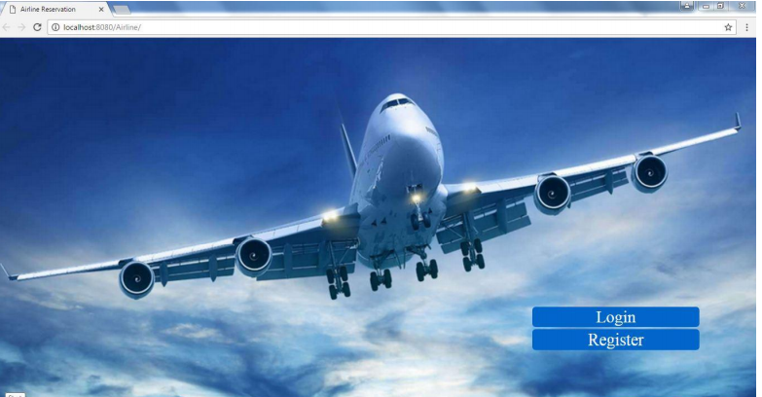

|  |
| --- |
| Top of Form  Bottom of Form |
|  |

// Login.jsp

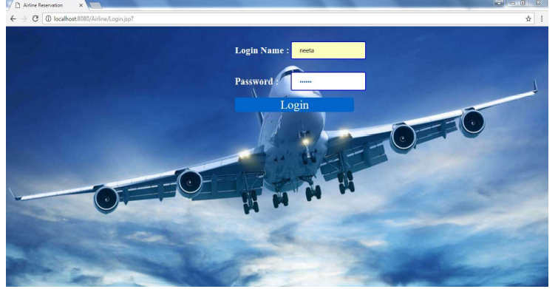

//Login.java

When Login Successful.

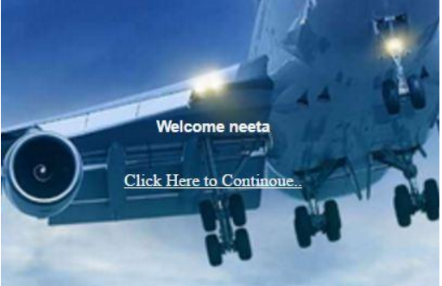

//Register.jsp

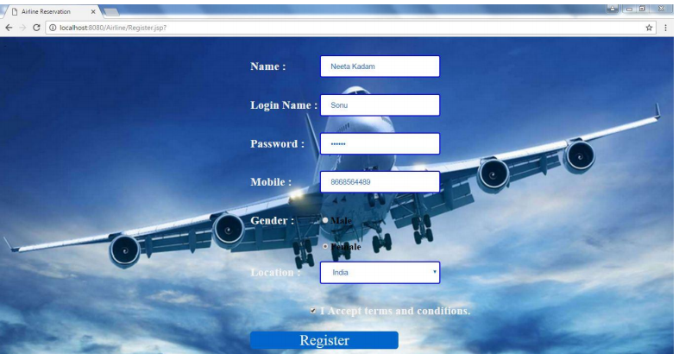

//Register.java

When Registration is successful

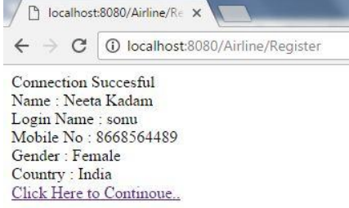

//Home.jsp

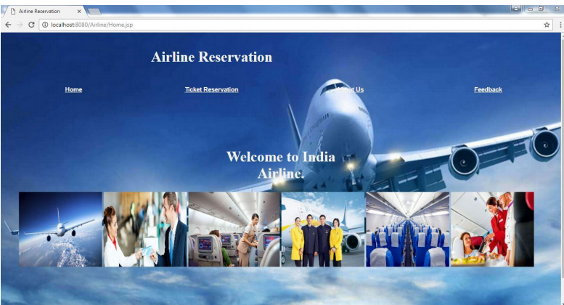

//TicketResevation.jsp

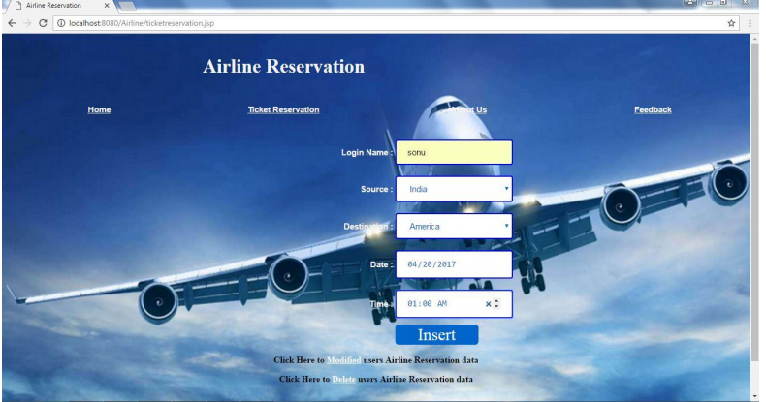

//Operation.jsp (TicketReservation Data inserted into Mysql Through this jsp page)

When Successfully inserted data:

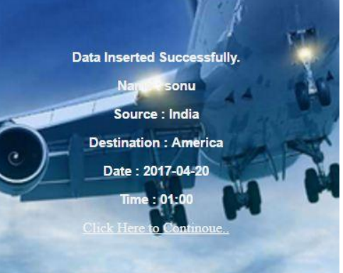

// Update.jsp

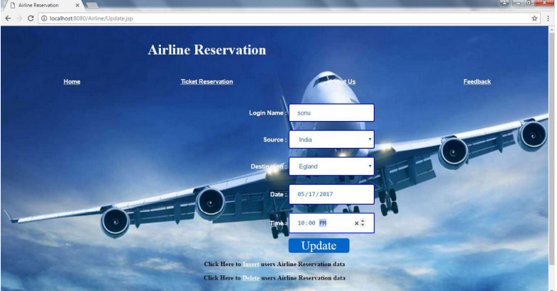

//UpdateData.jsp

When Data Updated Successfully..



//Delete.jsp

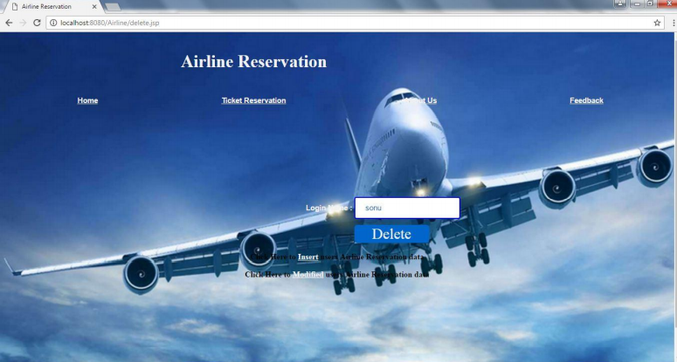

//DeleteData.jsp

After Delete.

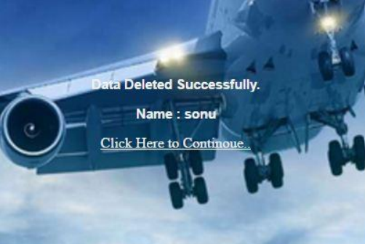

//Aboutus.jsp

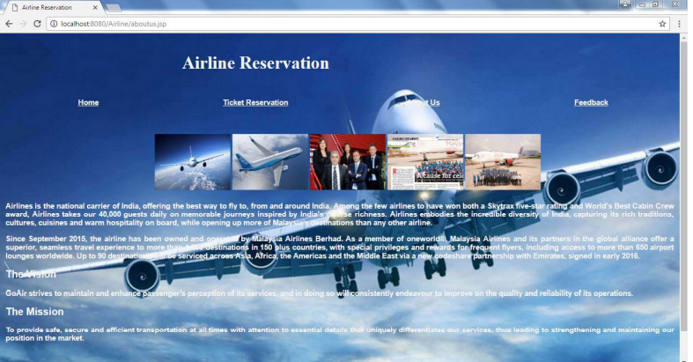

//Feedback.jsp

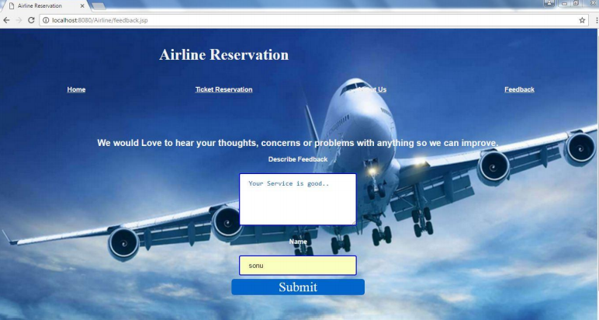

//feedbackData.jsp



**SOURCE CODE:**

**//Index.html:**

**Top of Form**

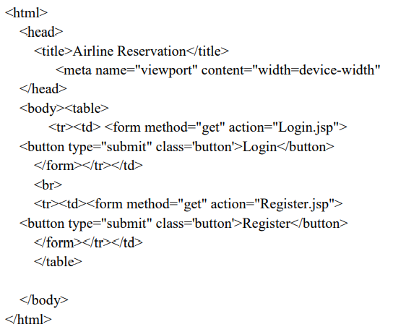

**// Login.jsp**

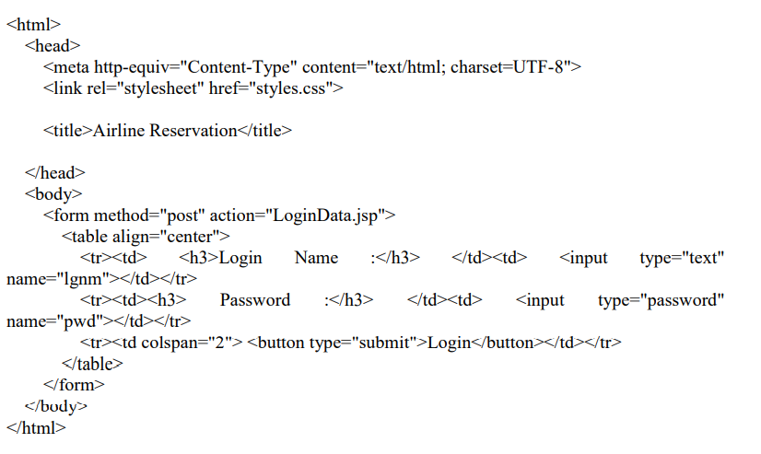

**//Login.java**

**package Register;**

**import java.io.IOException;**

**import java.io.PrintWriter;**

**import javax.servlet.ServletException;**

**import javax.servlet.http.HttpServlet;**

**import javax.servlet.http.HttpServletRequest;**

**import javax.servlet.http.HttpServletResponse;**

**import java.sql.*;public class Login extends HttpServlet {**

**protected void doPost(HttpServletRequest req, HttpServletResponse resp)**

**throws ServletException, IOException {**

**resp.setContentType("text/html;charset=UTF-8");**

**PrintWriter out = resp.getWriter();**

**Connection c1=null;**

**Statement st=null;**

**ResultSet rs1;**

**String q="";**

**try {**

**String lgnm1=req.getParameter("lgnm");**

**String ps1=req.getParameter("pwd");**

**Class.forName("com.mysql.jdbc.Driver").newInstance();**

**c1=DriverManager.getConnection("jdbc:mysql://localhost/airline","root","");**

**st=c1.createStatement();**

**q="select * from user where lname='"+lgnm1+"' and password='"+ps1+"'";**

**rs1=st.executeQuery(q);**

**if(rs1.next())**

**{**

**out.println("<html>");**

**out.println("<head>");**

**out.println("<link rel='stylesheet' href='style1.css'>");**

**out.println("Welcome, "+lgnm1+"<br>");**

**out.println("<a href='Home.jsp'>Click Here to Continoue..</a>");**

**out.println("</body>");**

**out.println("</body>");**

**}**

**else**

**{**

**out.println("Invalid Login<br>");**

**out.println("<a href='Login.jsp'>Try Again</a>");**

**}**

**}**

**catch(Exception e){ }**

**}**

**}**

**//Register.jsp**

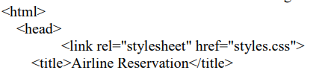

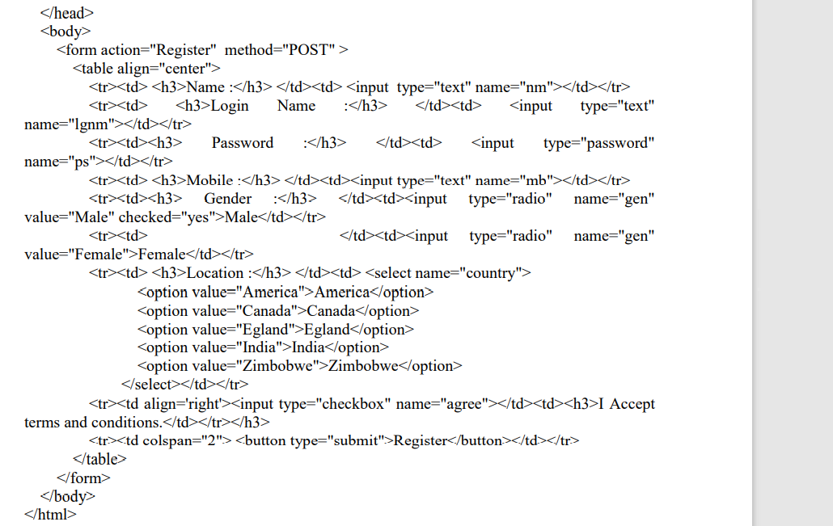

**//Register.java**

**package Register;**

**import java.io.*;**

**import javax.servlet.*;**

**import javax.servlet.http.*;**

**import java.sql.*;**

**public class Register extends HttpServlet {**

**protected void doPost(HttpServletRequest req, HttpServletResponse res)**

**throws ServletException, IOException {**

**res.setContentType("text/html");**

**PrintWriter out = res.getWriter();**

**Connection c1=null;**

**Statement st=null;**

**String q="";**

**try {**

**String nm1=req.getParameter("nm");**

**String lgnm1=req.getParameter("lgnm");**

**String ps1=req.getParameter("ps");**

**String mb1=req.getParameter("mb");**

**String gen1=req.getParameter("gen");**

**String country1=req.getParameter("country");**

**Class.forName("com.mysql.jdbc.Driver").newInstance();**

**c1=DriverManager.getConnection("jdbc:mysql://localhost/airline","root","");**

**out.println("Connection Succesful<br>");**

**st=c1.createStatement();**

**q="insert into user(name,lname,password,mobile,gen,country)**

**values('"+nm1+"','"+lgnm1+"','"+ps1+"','"+mb1+"','"+gen1+"','"+country1+"')"; st.executeUpdate(q); out.println("Name : "+nm1+"  
"); out.println("Login Name : "+lgnm1+"  
"); out.println("Mobile No : "+ mb1+"  
"); out.println("Gender : "+ gen1+"  
"); out.println("Country : "+ country1+"  
"); out.println("**[**Click Here to Continoue..**](Home.jsp)**"); } catch(Exception e) { out.println("Connection Fail..")**

**}**

**}**

**}**

**//Home.jsp**

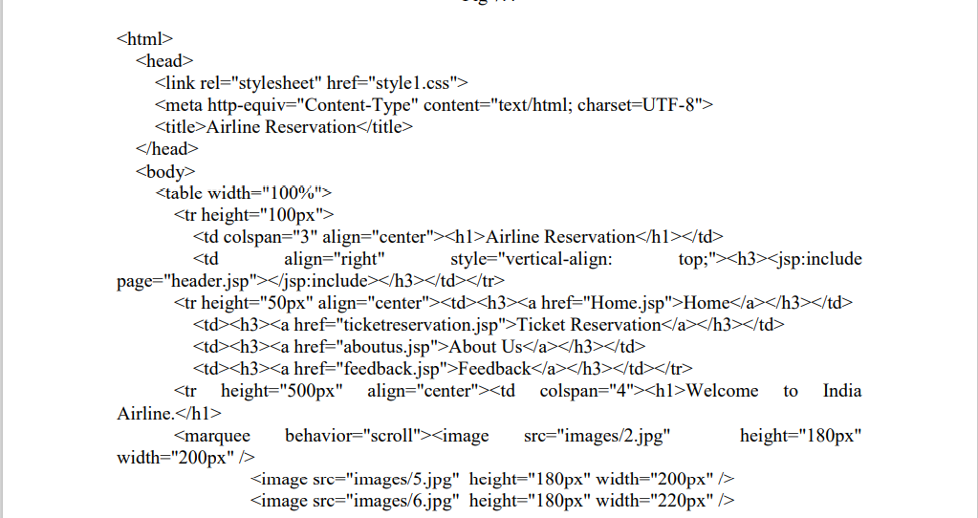

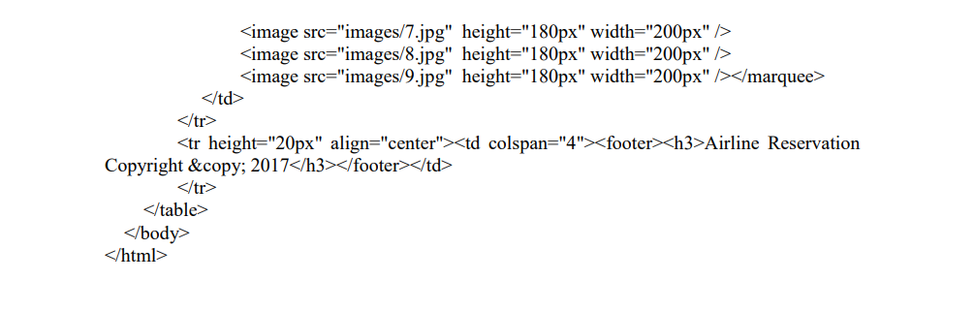

**//TicketResevation.jsp**

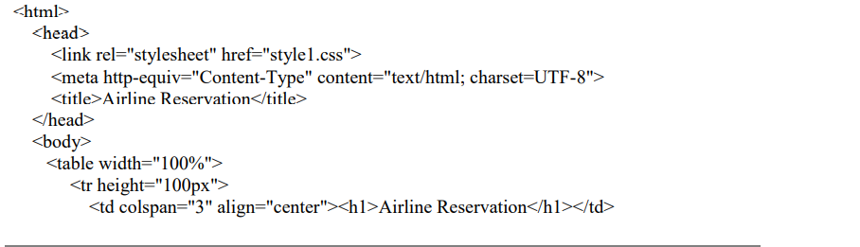

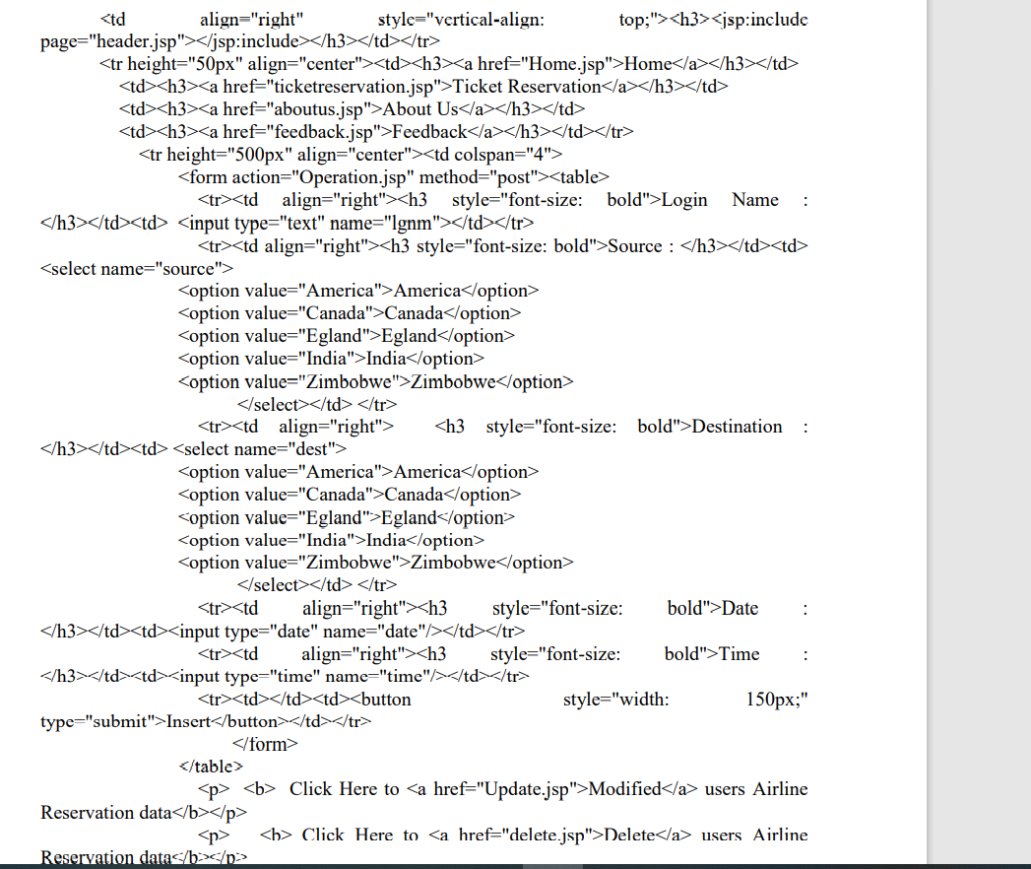

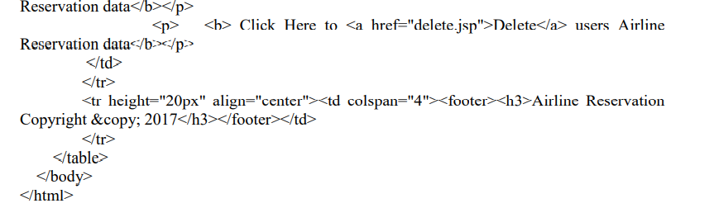

**//Operation.jsp**

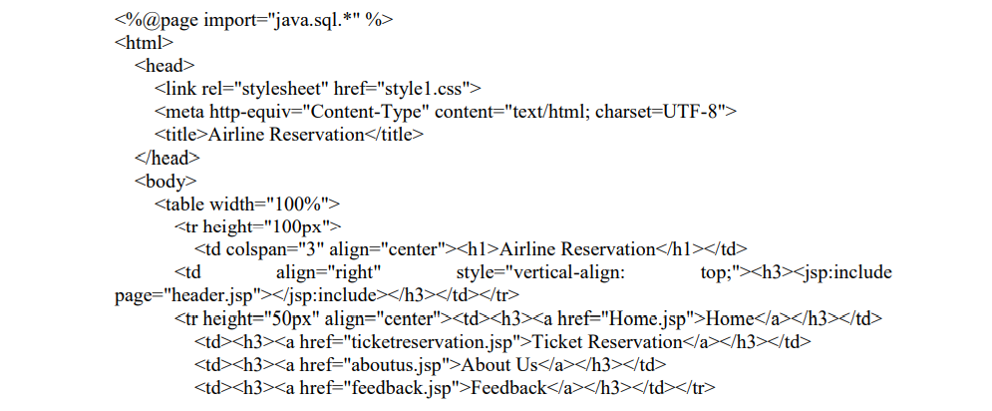

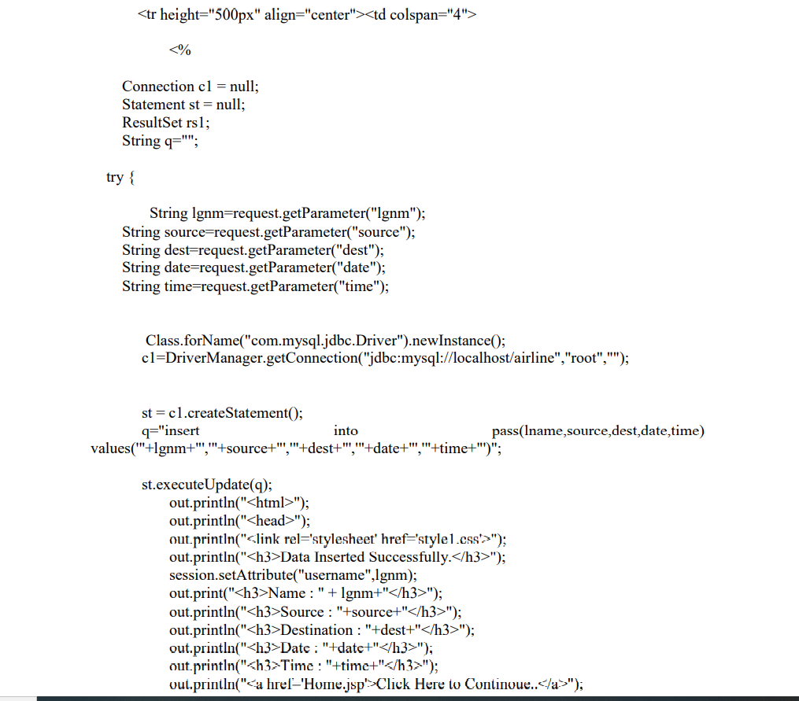

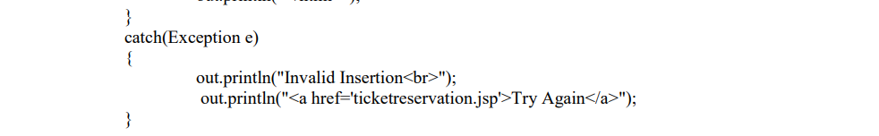

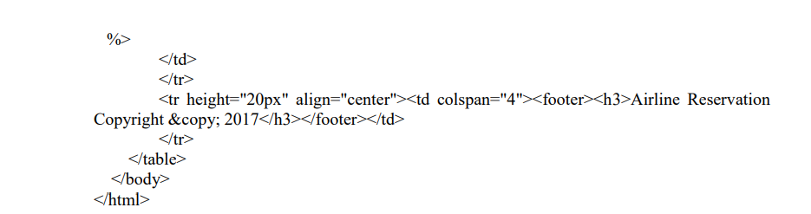

**// Update.jsp**

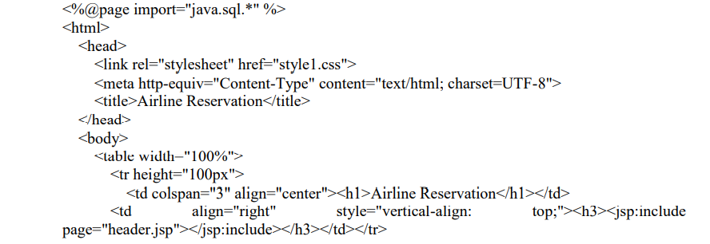

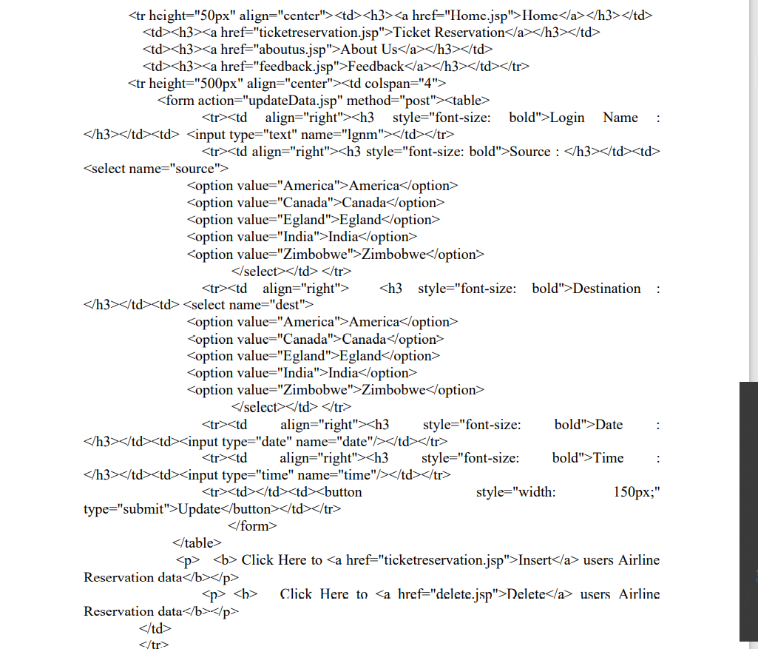

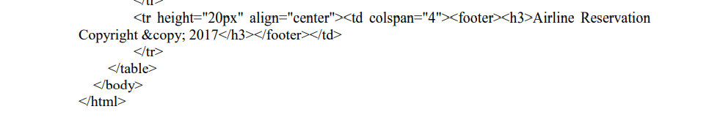**//UpdateData.jsp**

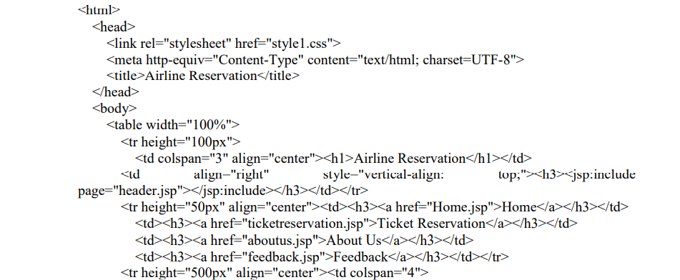

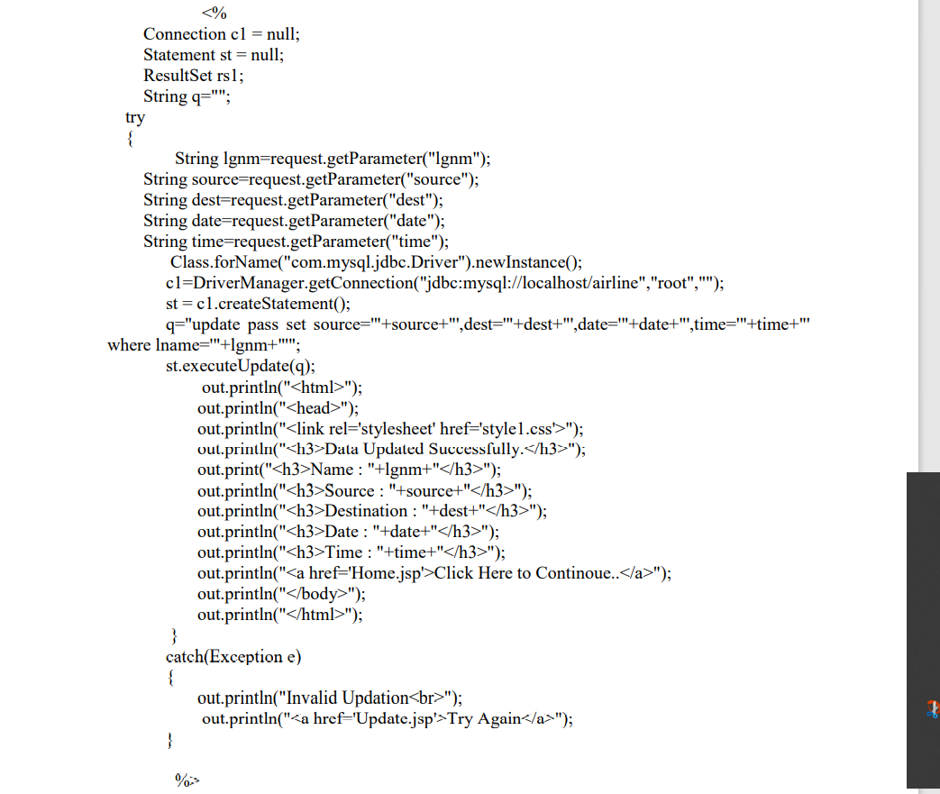

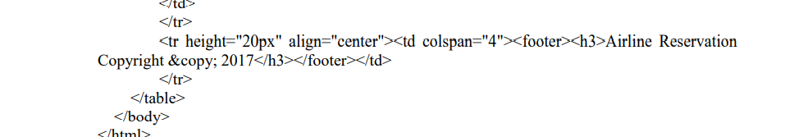

**//Delete.jsp**

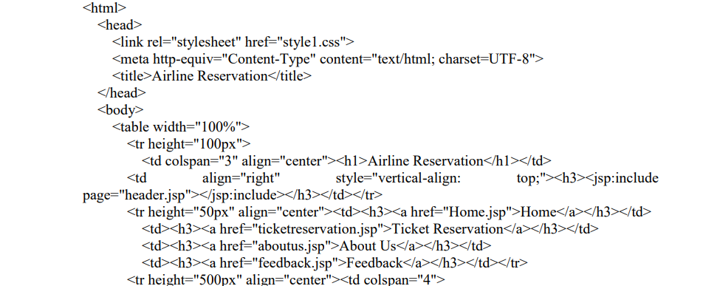

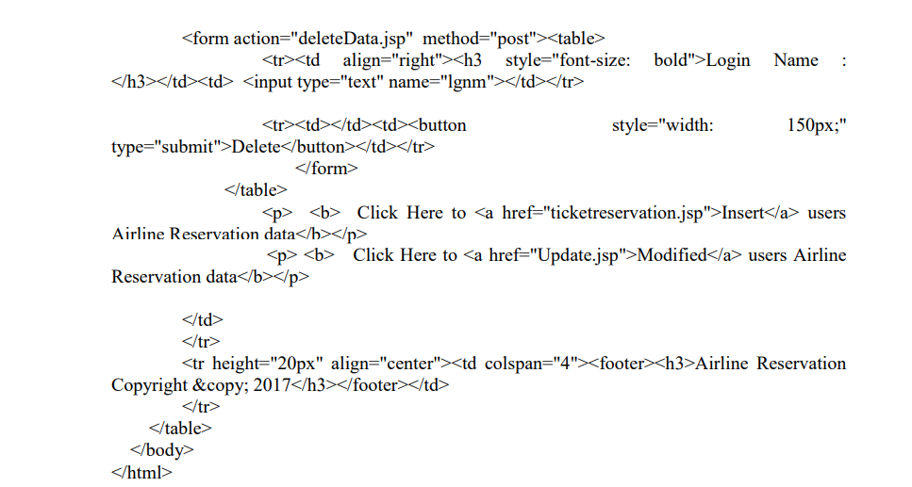

**//DeleteData.jsp**

**After Delete.**

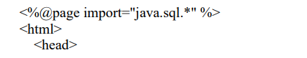

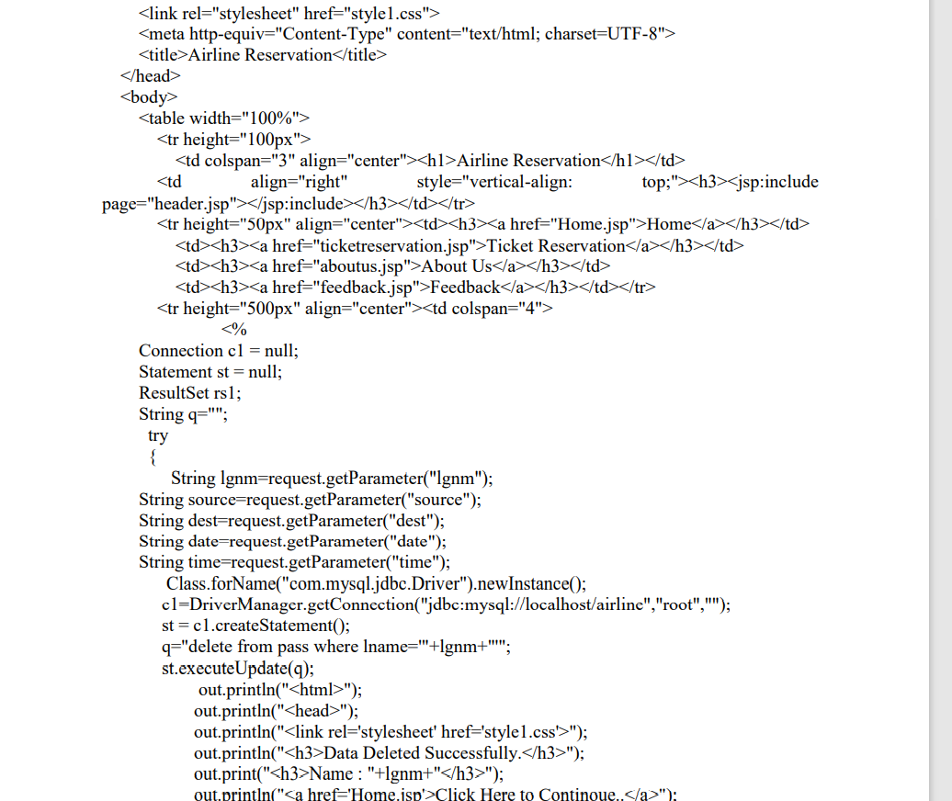

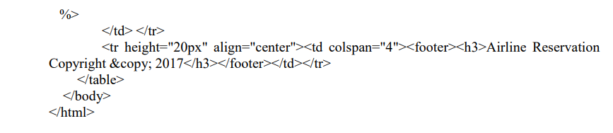

**//Aboutus.jsp**

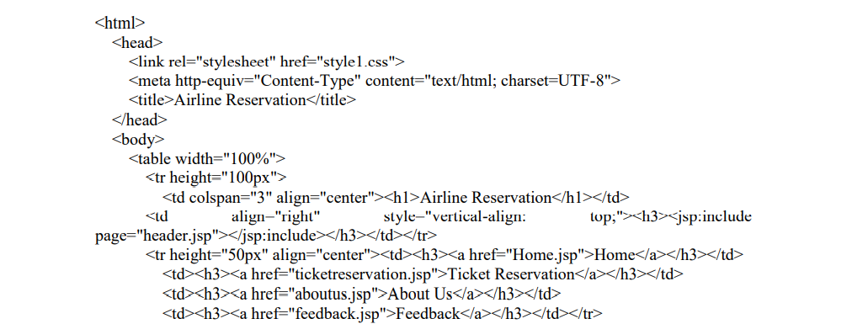

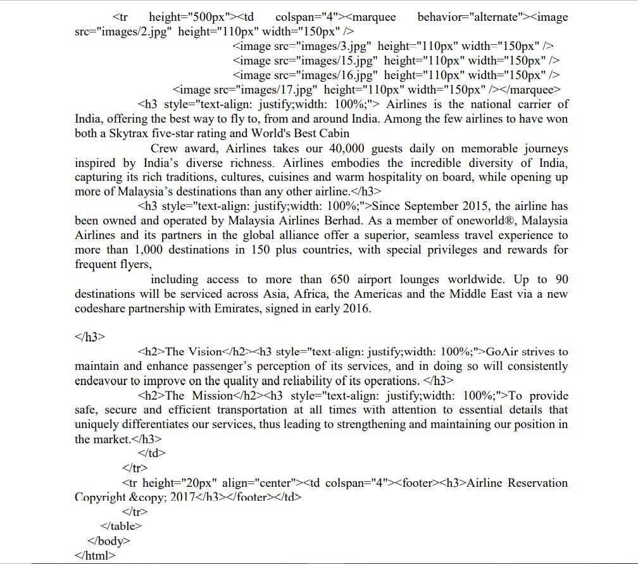

**//Feedback.jsp**

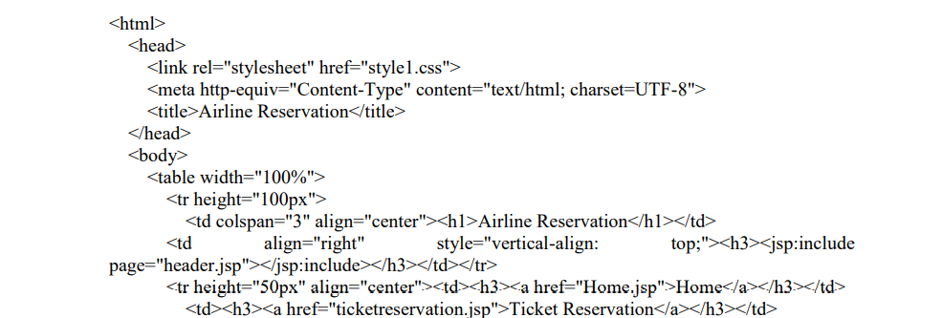

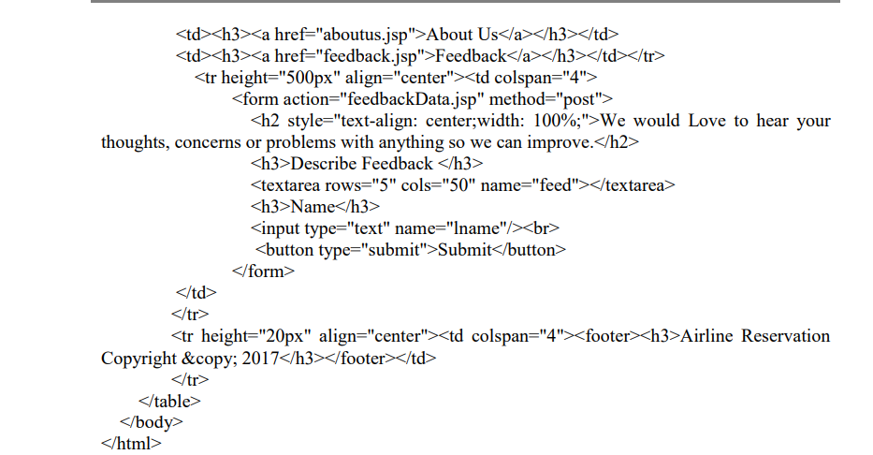

**//feedbackData.jsp**

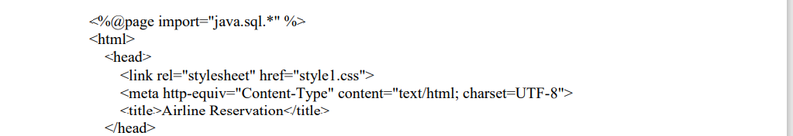

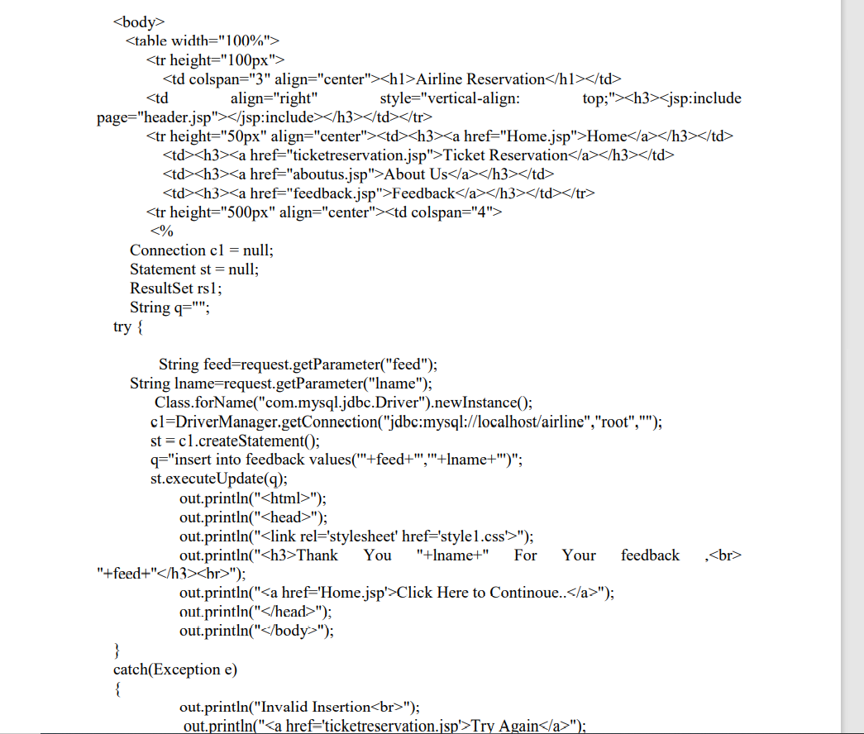

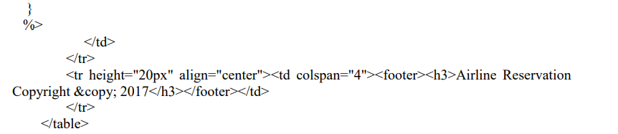

**</body>**

**</HTML>**

**We use here a Cascading Style Sheets.**

**//Style1.css**

